# Red Team: Summary of Operations

## 

## Table of Contents

* Exposed Services
* Critical Vulnerabilities
* Exploitation

### Exposed Services

Nmap scan from within msfconsole results for each machine reveal the below services and OS details

Target 1 - nmap -v -sV 192.168.1.110

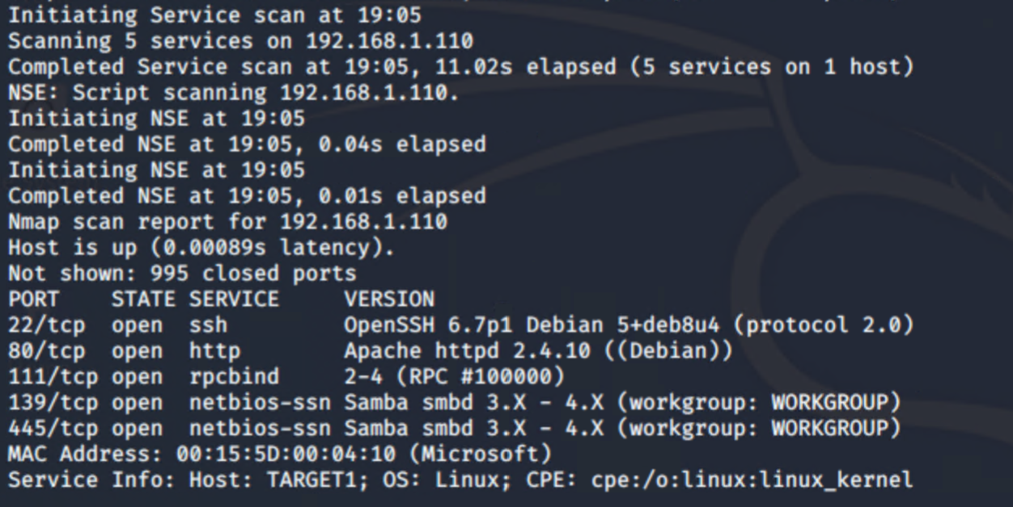

Target 2 - nmap -v -sV 192.168.1.115

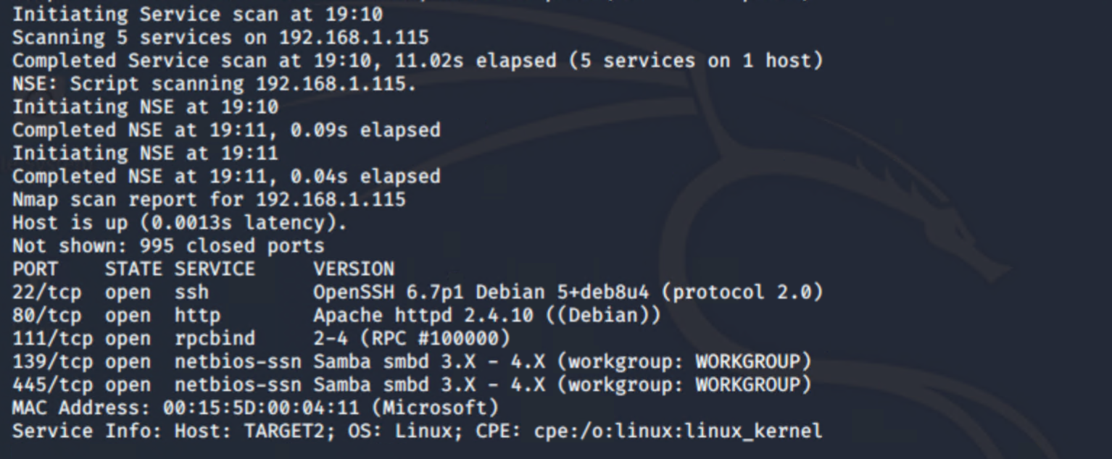

This scan identifies the services below as potential points of entry:

**Target 1**

1. Port 22 Open - SSH
2. Port 80 Open - HTTP
3. Port 111 Open - rpcbind

**Target 2**

1. Port 22 Open - SSH
2. Port 80 Open - HTTP
3. Port 111 Open - rpcbind

Further scans with Nikto and WPScan:

Nikto Target 1

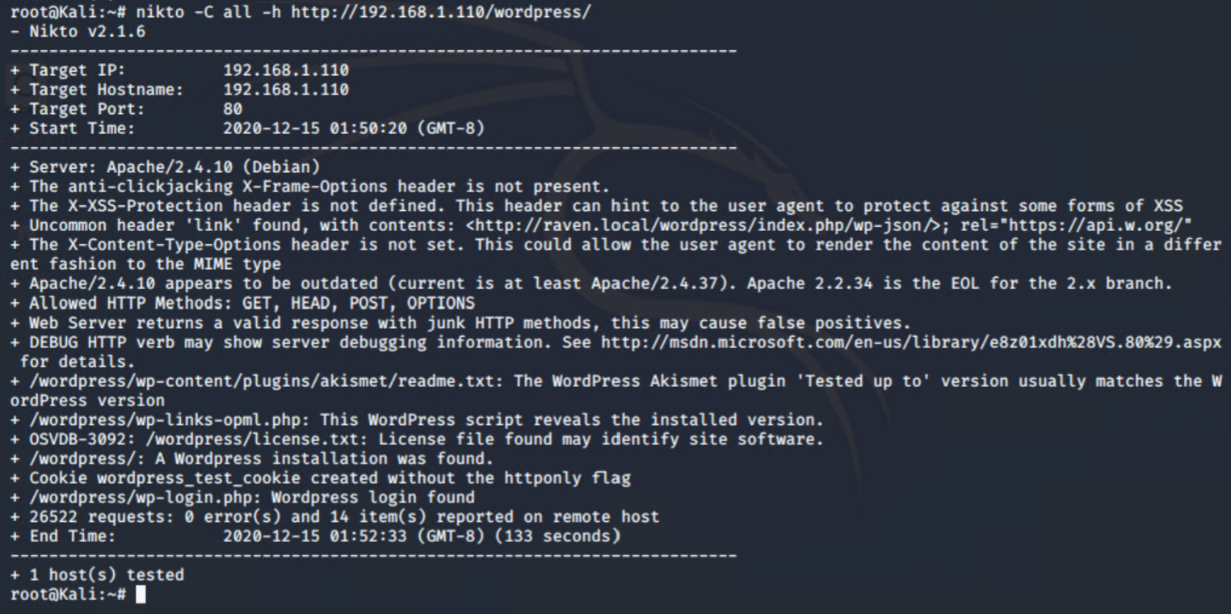

Nikto Target 2

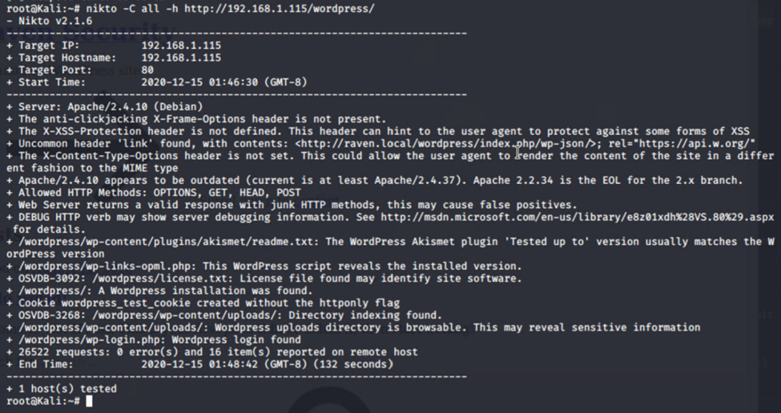

WP Scan Target 1

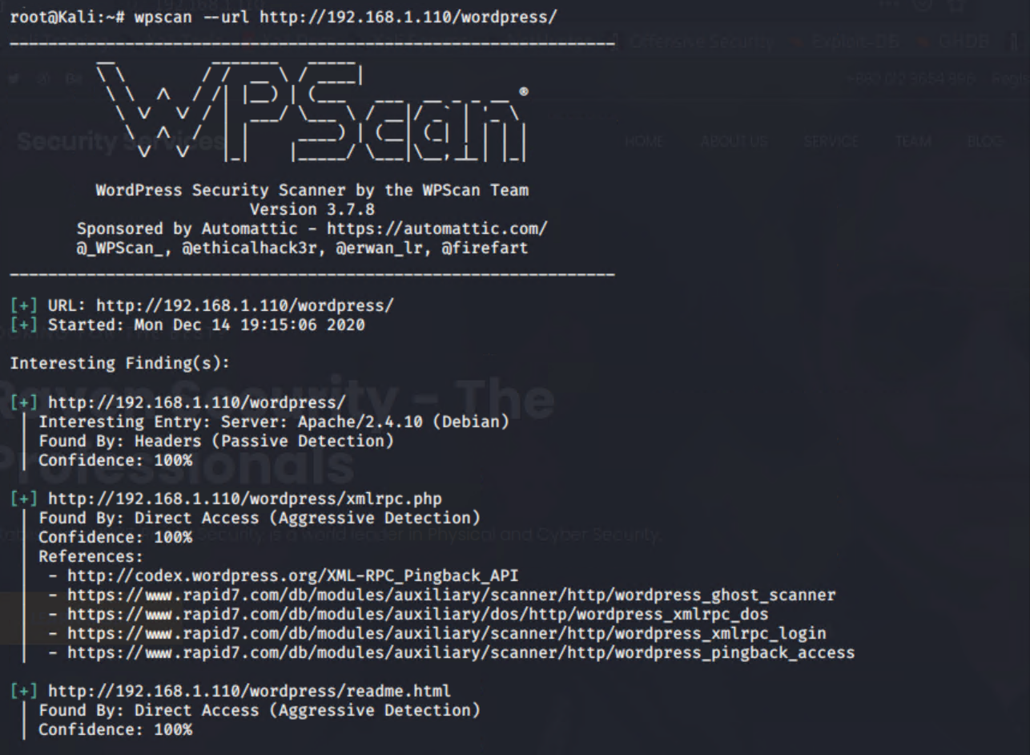

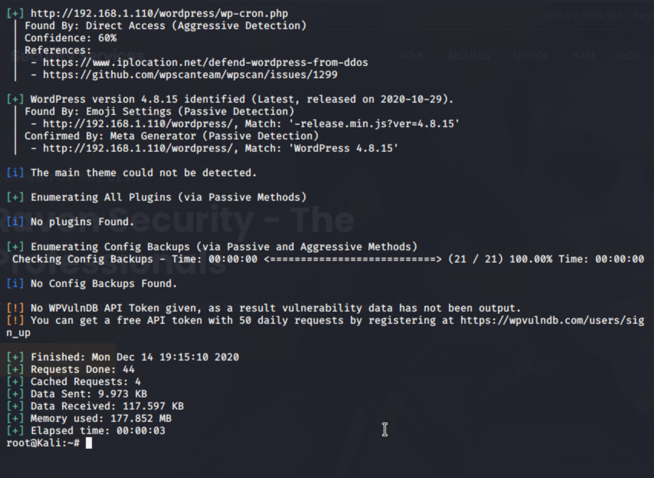

Target 2

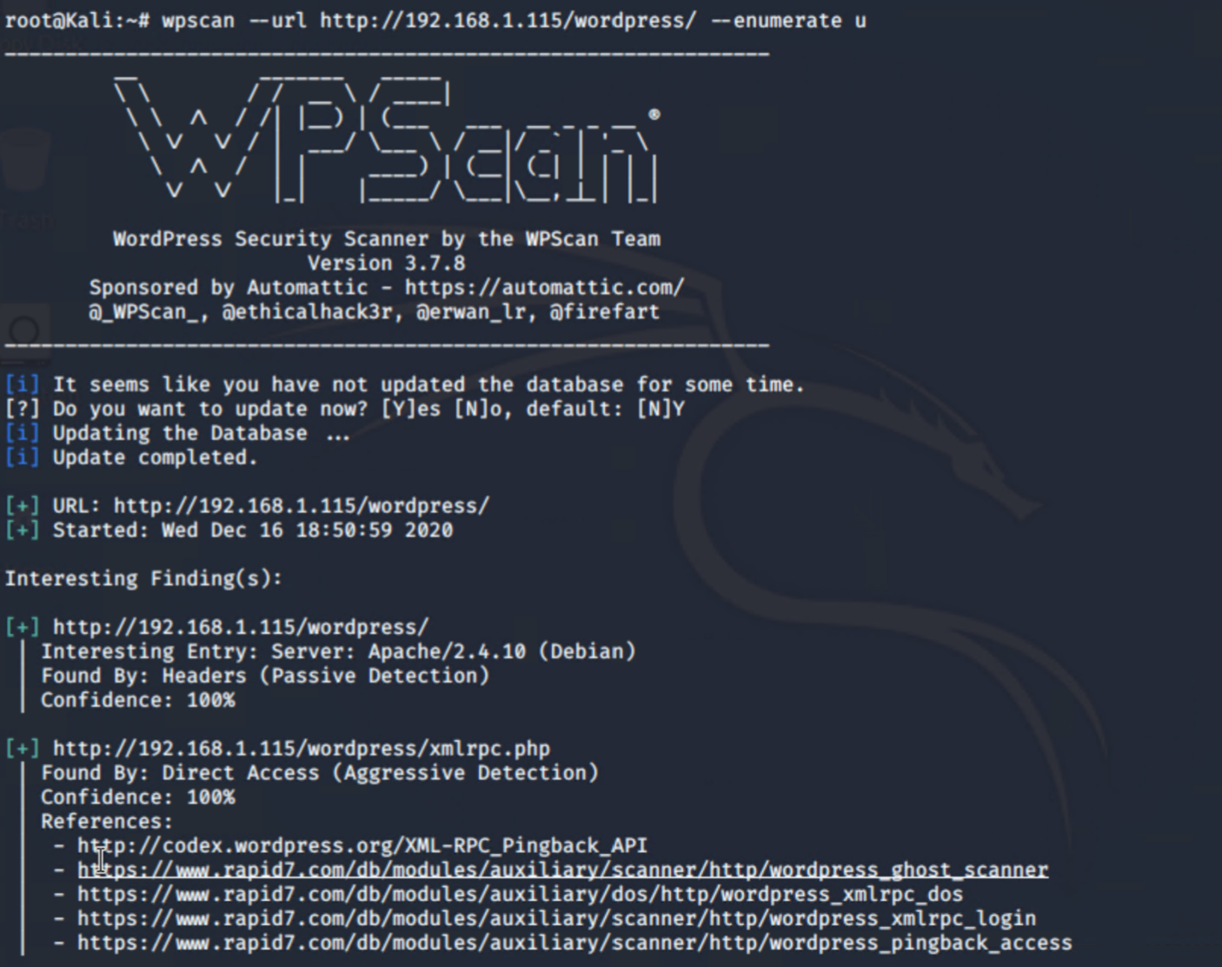

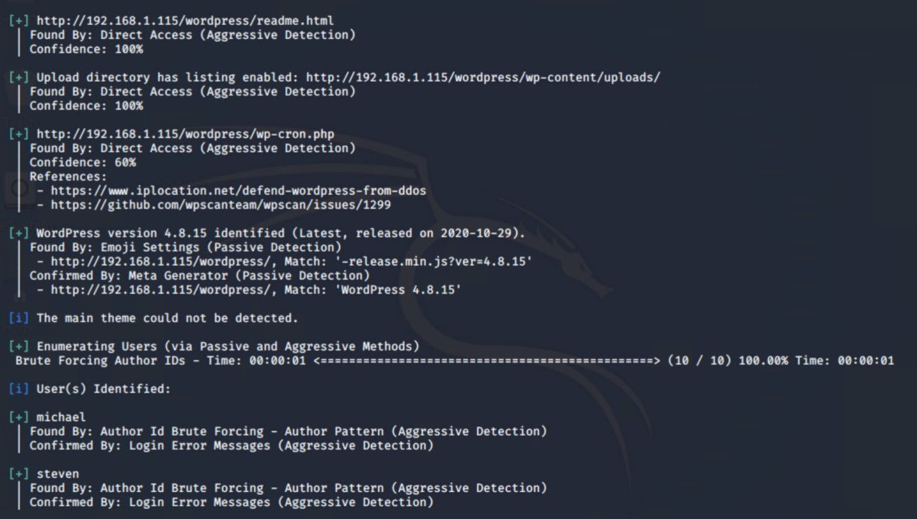

### Critical Vulnerabilities

The following vulnerabilities were identified on each target:

**CVE-2016-6210:** sshd in OpenSSH before 7.3, when SHA256 or SHA512 are used for user password hashing, uses BLOWFISH hashing on a static password when the username does not exist, which allows remote attackers to enumerate users by leveraging the timing difference between responses when a large password is provided.

**Rating: 5.9 Medium**

**Mitigation:** Upgrade OpenSSH to version 7.3 or later

**CVE-2016-6515:** The auth_password function in auth-passwd.c in sshd in OpenSSH before 7.3 does not limit password lengths for password authentication, which allows remote attackers to cause a denial of service (crypt CPU consumption) via a long string.

**Rating**: **7.5 High**

**Mitigation:** Upgrade OpenSSH to version 7.3 or later

**CVE-2015-8325:** The do_setup_env function in session.c in sshd in OpenSSH through 7.2p2, when the UseLogin feature is enabled and PAM is configured to read .pam_environment files in user home directories, allows local users to gain privileges by triggering a crafted environment for the /bin/login program, as demonstrated by an LD_PRELOAD environment variable.

**Rating: 7.8 High**

**Mitigation:** Upgrade OpenSSH to version 7.3 or later

**CVE-2015-5600:** The kbdint_next_device function in auth2-chall.c in sshd in OpenSSH through 6.9 does not properly restrict the processing of keyboard-interactive devices within a single connection, which makes it easier for remote attackers to conduct brute-force attacks or cause a denial of service (CPU consumption) via a long and duplicative list in the ssh -oKbdInteractiveDevices option, as demonstrated by a modified client that provides a different password for each pam element on this list.

**Rating: N/A**

**Mitigation:** Upgrade OpenSSH to version 7.3 or later

**CVE-2017-7679:** In Apache httpd 2.2.x before 2.2.33 and 2.4.x before 2.4.26, mod_mime can read one byte past the end of a buffer when sending a malicious Content-Type response header.

**Rating: 9.8 CRITICAL**

**Mitigation:** Upgrade Apache to version 2.4.26 or later

**CVE-2017-7668:** The HTTP strict parsing changes added in Apache httpd 2.2.32 and 2.4.24 introduced a bug in token list parsing, which allows ap_find_token() to search past the end of its input string. By maliciously crafting a sequence of request headers, an attacker may be able to cause a segmentation fault, or to force ap_find_token() to return an incorrect value.

**Rating: 9.8 CRITICAL**

**Mitigation:** Upgrade Apache to version 2.4.26 or later

**CVE-2017-3169:** In Apache httpd 2.2.x before 2.2.33 and 2.4.x before 2.4.26, mod_ssl may dereference a NULL pointer when third-party modules call ap_hook_process_connection() during an HTTP request to an HTTPS port.

**Rating: 9.8 CRITICAL**

**Mitigation:** Upgrade Apache to version 2.4.26 or later

**CVE-2017-3167:** In Apache httpd 2.2.x before 2.2.33 and 2.4.x before 2.4.26, use of the ap_get_basic_auth_pw() by third-party modules outside of the authentication phase may lead to authentication requirements being bypassed.

**Rating: 9.8 CRITICAL**

**Mitigation:** Upgrade Apache to version 2.4.26 or later

**CVE-2020-4049:** In affected versions of WordPress, when uploading themes, the name of the theme folder can be crafted in a way that could lead to JavaScript execution in /wp-admin on the themes page. This does require an admin to upload the theme, and is low severity self-XSS. This has been patched in version 5.4.2, along with all the previously affected versions via a minor release (5.3.4, 5.2.7, 5.1.6, 5.0.10, 4.9.15, 4.8.14, 4.7.18, 4.6.19, 4.5.22, 4.4.23, 4.3.24, 4.2.28, 4.1.31, 4.0.31, 3.9.32, 3.8.34, 3.7.34).

**Rating: 2.4 Low**

**Mitigation:** Upgrade Wordpress to version 5.4.2

Exploitation

**Target 1**

SSH to target as user michael

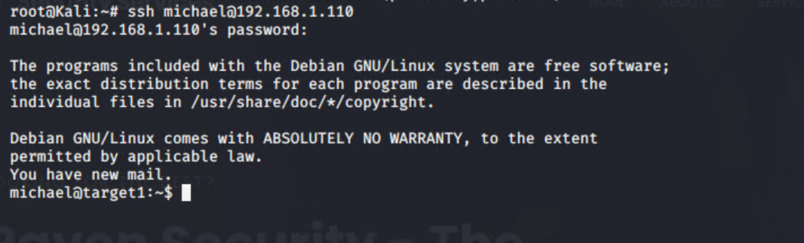

Navigated to /var/www/html/wp-config.php file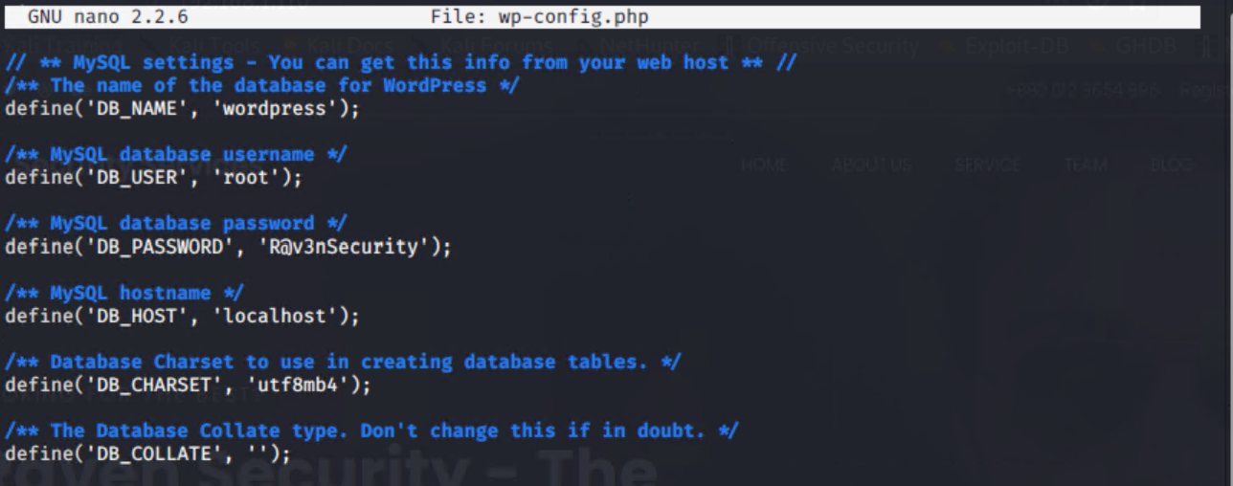

Used Credential to log into MYSQL

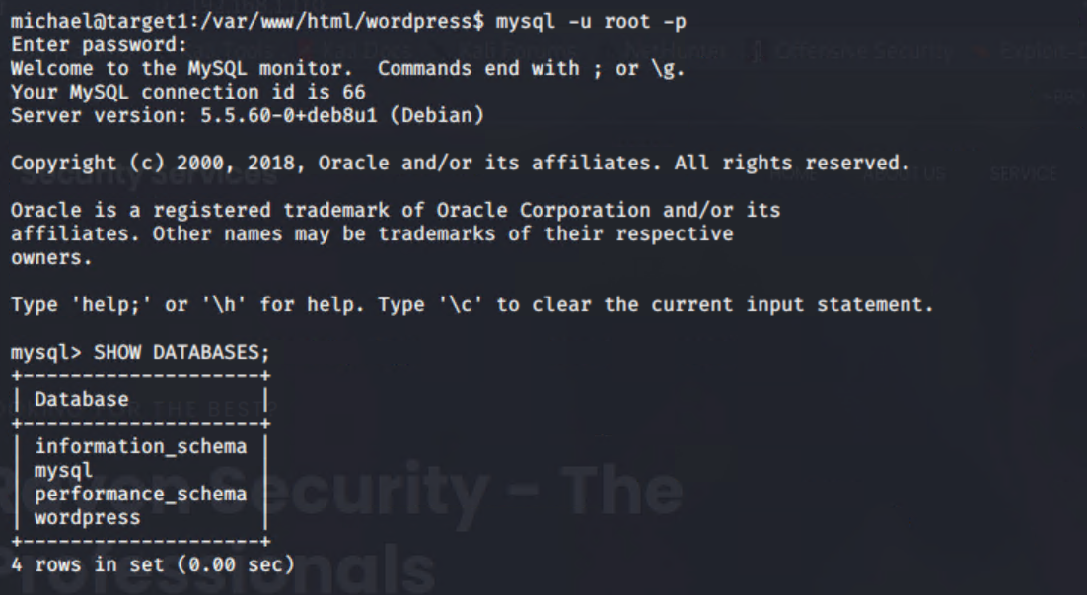

And collected password hashes

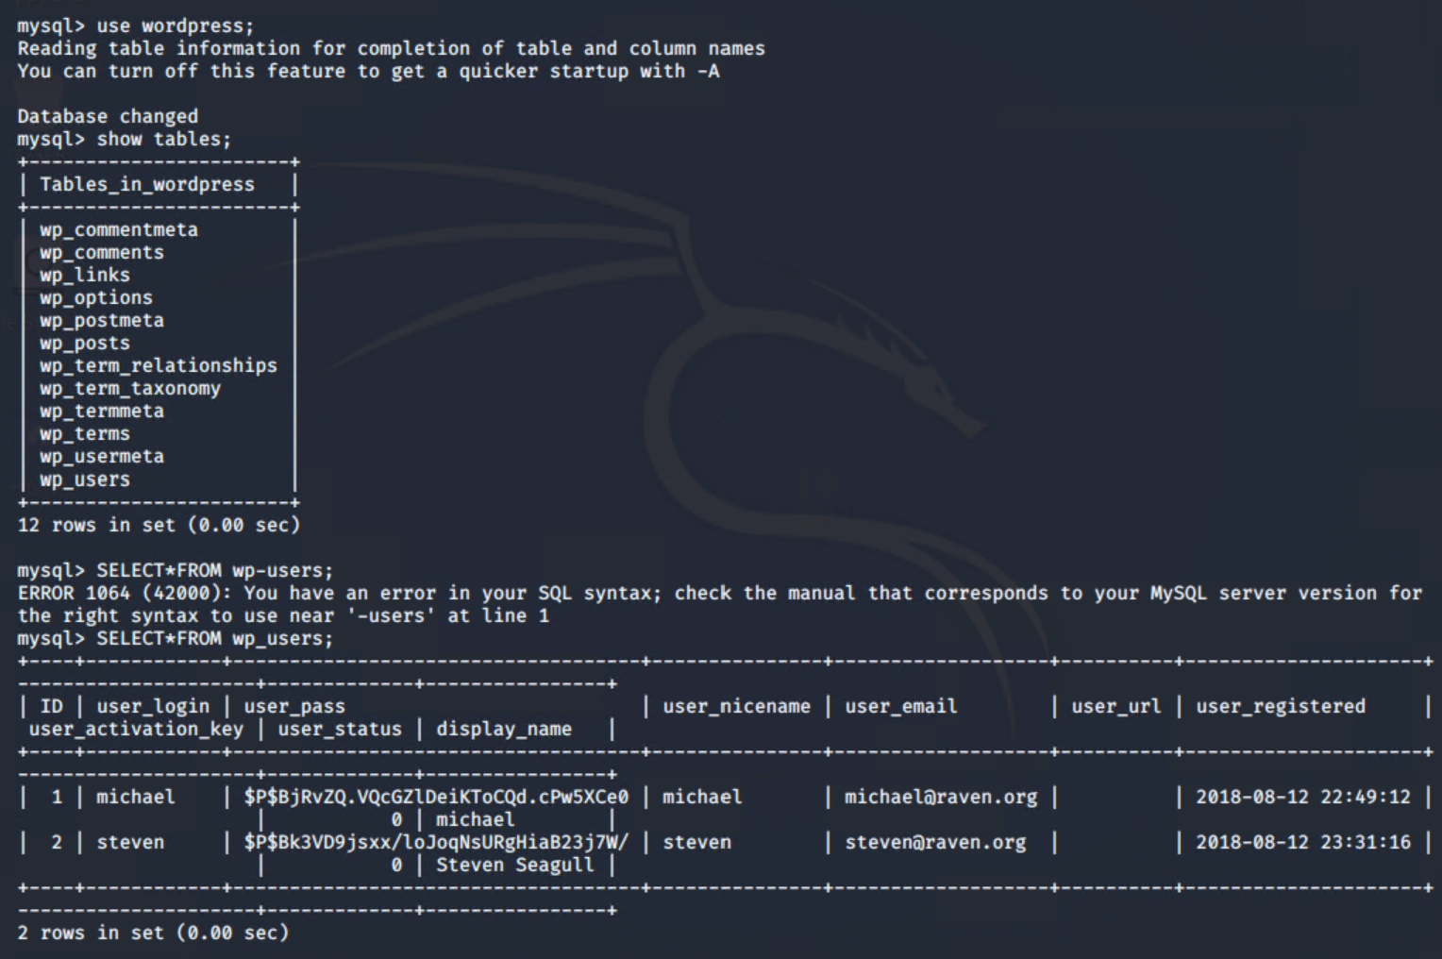

Created a password file ‘wp_hashes.txt’ and used John the ripper

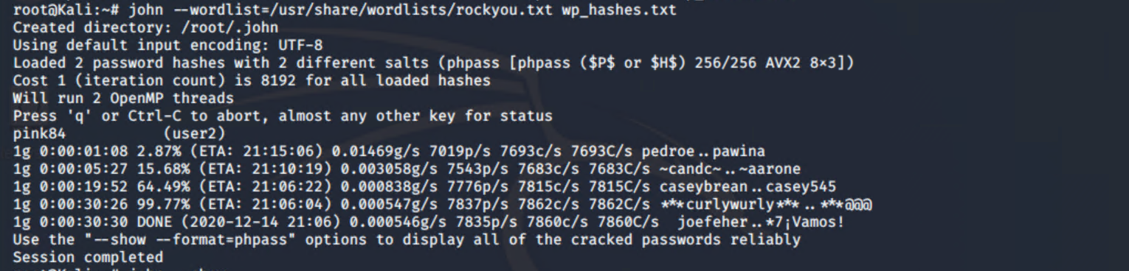

Logged on as Steven

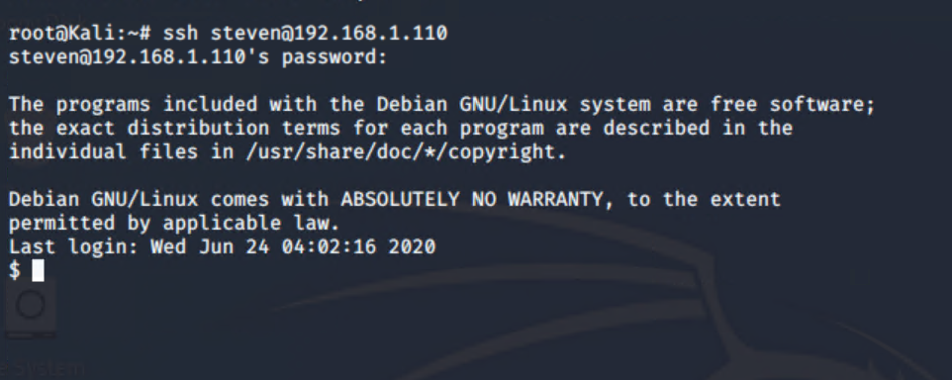

And escalated to ‘root’ using a sudo exploit and python (Final Flag)

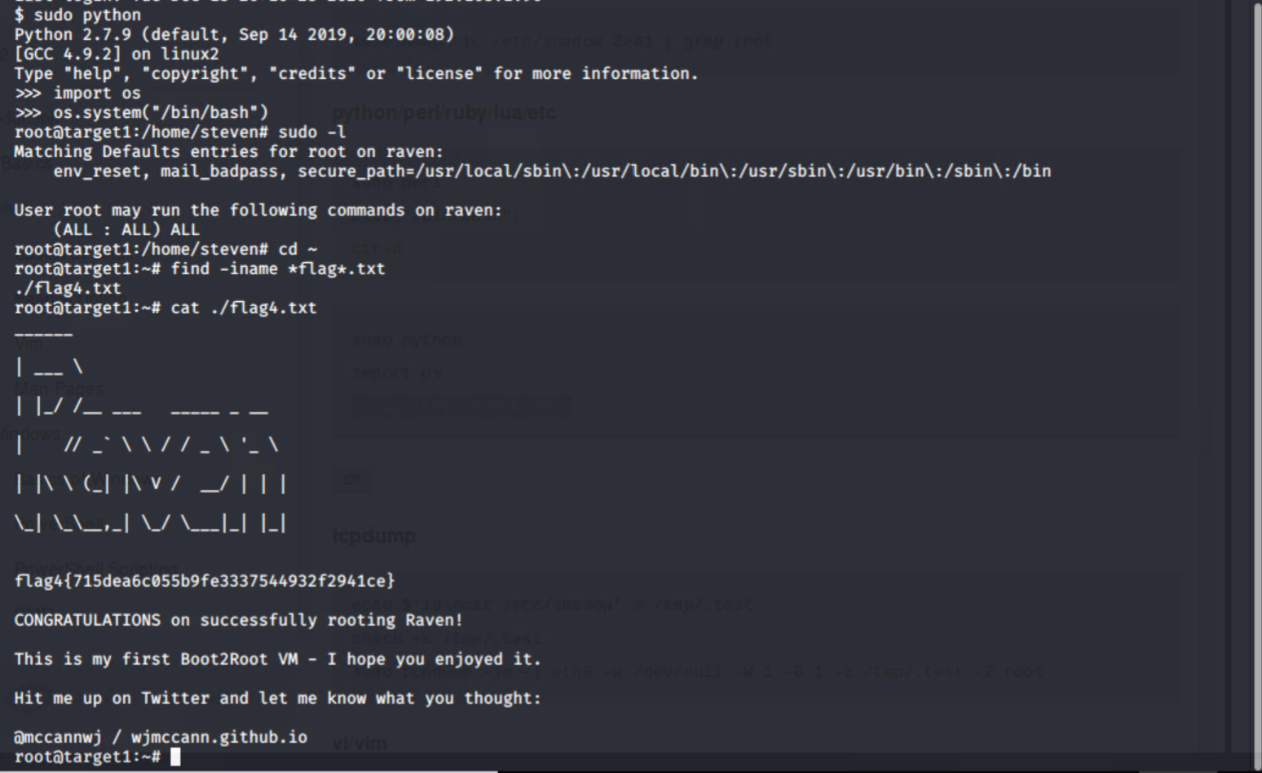

**Target 2**

As with Target 1 MYSQL credentials were available and a connection could be made

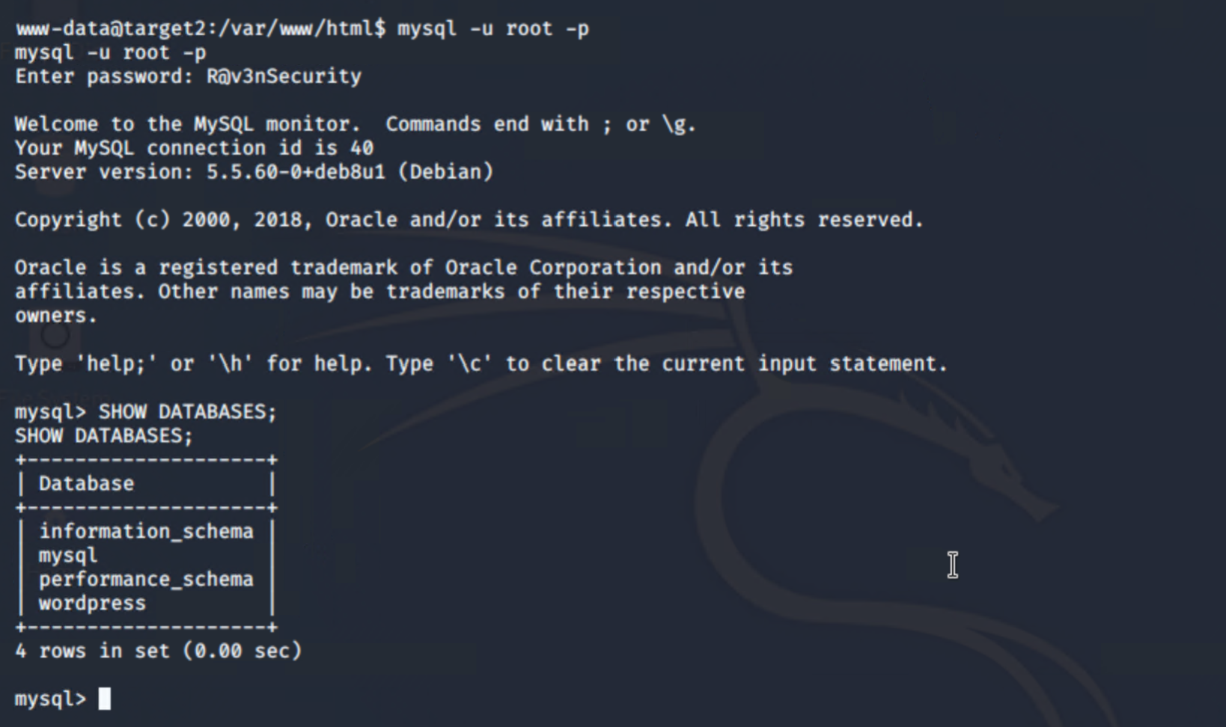

Password hashes could be shown

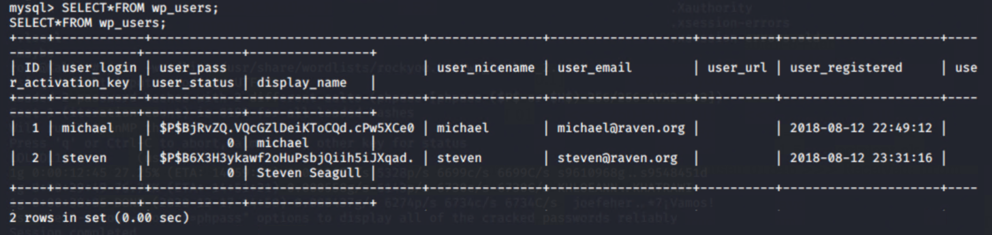

John the ripper was able to crack user 2 steven

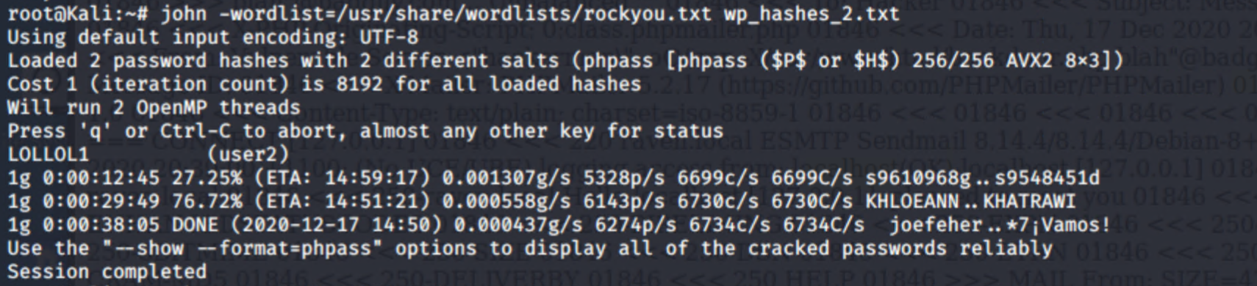

Navigating to the /vendor folder showed phpmailer. The /VERSION folder shows version 5.2.16

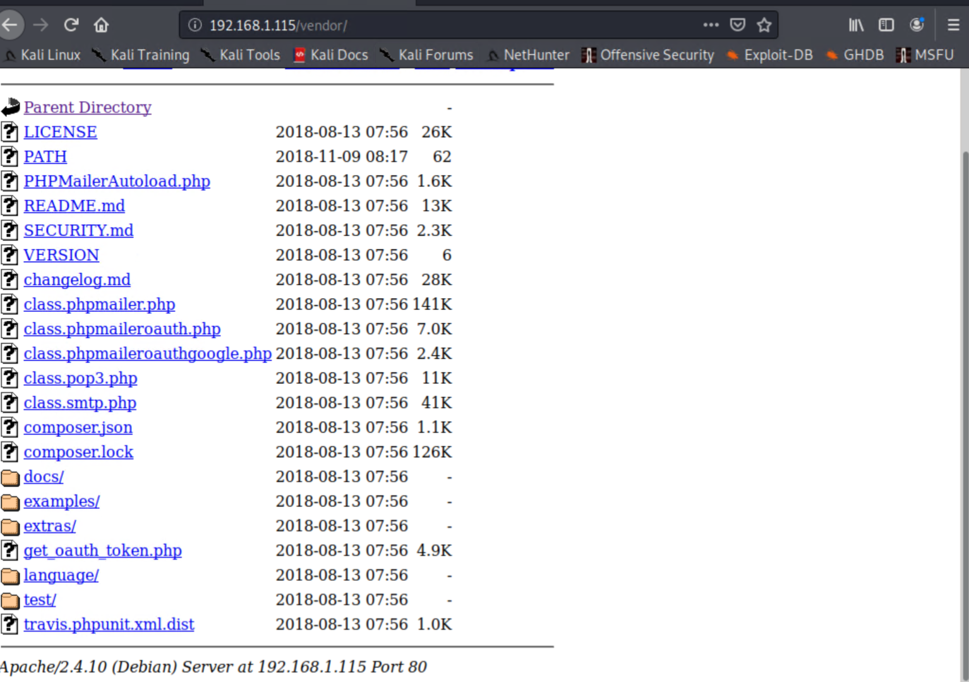

Searchsploit exposed a number of vulnerabilities

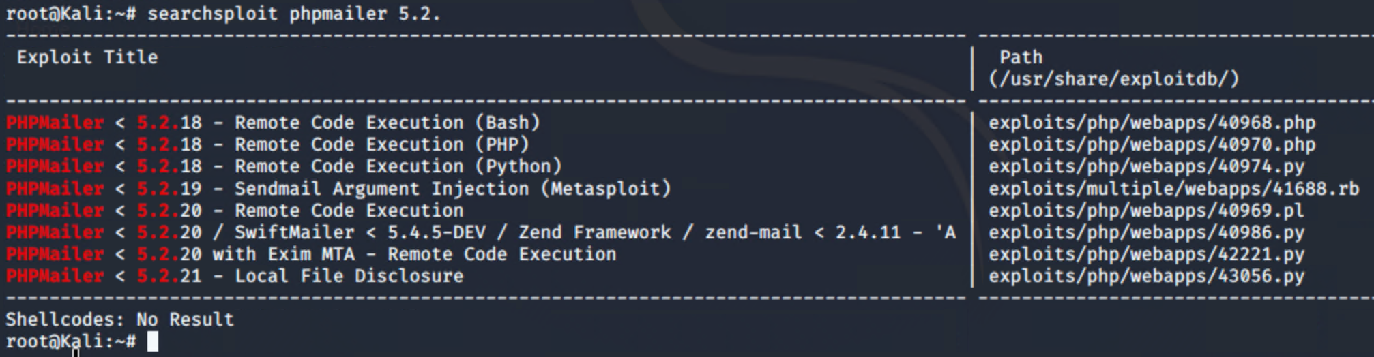

Target 2 flags

